Temporary Exhibits

FIRST FLOOR:

(2) From Shangri-La to Tokyo – An exhibit exploring the daring Tokyo Raid that boosted U.S. morale after the bombing of Pearl Harbor.

(6) Manufacturing Victory: The Arsenal of Democracy – On loan from the National WWII Museum in New Orleans, LA. Manufacturing Victory tells the inspiring story of the Home Front effort that produced tanks, planes, ships, and guns with staggering speed and unparalleled energy.

(7) War and Remembrance – Learn how photos, letters, other memorabilia and events help us to understand the Civil War perspective through memory and time.

(8) Undaunted Courage – Undaunted Courage looks closely at the treatment of Japanese Americans during WWII and the service of Japanese American men who served their country while at home their loved ones were being moved to internment camps.

SECOND FLOOR:
(2) Imagery and Irony – Set within the First Call gallery, this exhibit focuses on the political cartoons of Nina Allender and their relationship to World War I propaganda posters, while exploring her influence on the women’s suffragist movement.

(Meeting Room) The Color of Freedom - This interactive display includes the stories of twenty-one servicewomen of color, and brings to light the impact that these women made while serving in various branches of the U.S. military.

Now Showing in the Tower Theatre:

The MacArthur Story

Film lasts approx. 22 minutes and plays on a loop.

Audio Tour
Access audio tour by scanning QR code or visiting:
www.mmamh.stqry.app

Permanent Exhibits

FIRST FLOOR:
(1) From Turbulence to Tranquility – Learn the history of the Arsenal, established as a frontier military post in 1840, and subsequent uses of the site after the Arsenal closed in 1890.

(2) The Sun Never Sets on the Mighty Jeep – Featuring a 1943 Willys Jeep, this exhibit traces the development of the military vehicle during World War II.

(4) Civil War Gallery – Through a series of exhibits, this gallery explores Arkansas’s involvement in the Civil War through four major themes: Capitol in Crisis, The Little Rock Campaign, David O. Dodd, and The Camden Expedition.

SECOND FLOOR:
(1) Vietnam War Gallery – Using photographs taken by Arkansas natives Bruce Wesson and Jim Guy Tucker, along with artifacts belonging to decorated combat pilot Hugh Mills, explore our state’s involvement in the Vietnam War.

(2) First Call – Learn how posters were used as a highly effective means of shaping public opinion and calling civilians to action during World War I.

(3) Medal of Honor Gallery – This exhibit explores the medal’s history and the stories of those Arkansans who earned it along with other Medals of Honor awarded to Arkansans.

(4) Duty, Honor, Country – Learn more about MacArthur’s ties to Little Rock from his birth in the Arsenal building to his return visit in 1952.

ARSENAL TOUR

About the MacArthur Museum of Arkansas Military History

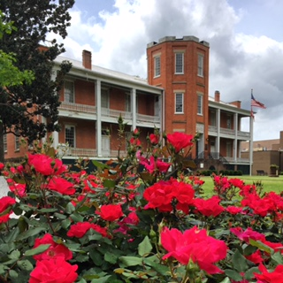
The Arsenal Building was constructed in 1840 as part of a frontier military post. The building originally housed weapons and munitions for soldiers, but in 1868 it was converted into housing for officers and their families. In 1879 Captain Arthur MacArthur was stationed here, and on January 26, 1880, Douglas MacArthur was born in this building. Douglas MacArthur became one of the foremost military leaders of the 20th Century. The military post was closed in 1892 and the grounds became Little Rock’s first public park. All structures except for the Arsenal Building were either moved or destroyed. The Arsenal Building opened as the MacArthur Museum of Arkansas Military History in 2001, dedicated to preserving our state’s rich military heritage. The museum is funded by the City of Little Rock and operated under its Parks and Recreation department.

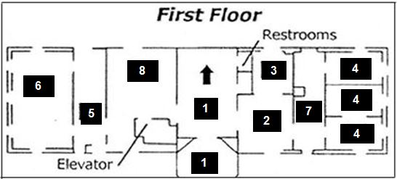

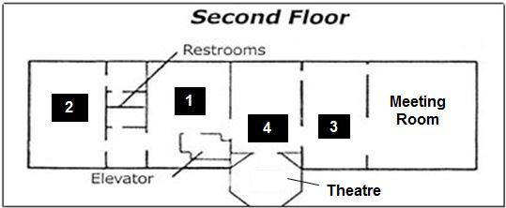
MacArthur Museum of Arkansas Military History
503 East 9th Street
Little Rock, AR 72202
(501) 376-4602
Hours of Operation: Email: macarthur@littlerock.gov
Tuesday-Saturday, 10:00 – 5:00
Sunday, 1:00 – 5:00
Closed Monday

Find us online at: https://www.littlerock.gov/macarthur

MacArthur Museum of Arkansas Military History

